Centro Educacional Brasil Portugal
Teacher: Márcia Cristine | Subject: English | Class:Pré 2
Name:_______________________________________________________

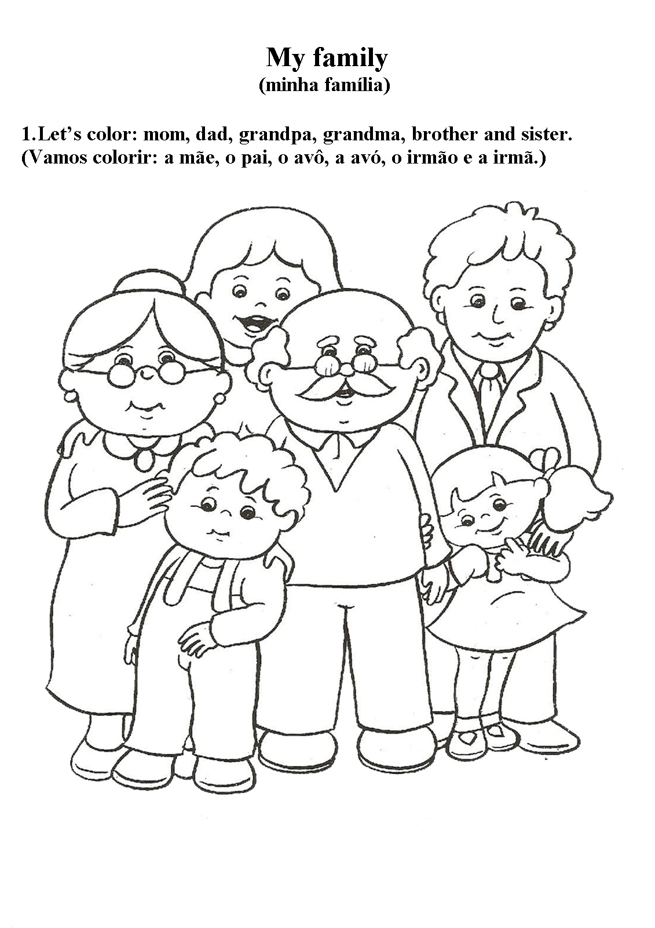
semana de 06/04 até 09/04/2020

